
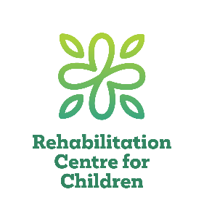
FASD Workshop/Presentation
Request Form

The Manitoba FASD Centre team members provide presentations and workshops on a variety of topics related to Fetal Alcohol Spectrum Disorder (FASD).
Name of Organization:
Click or tap here to enter text.
Address:Click or tap here to enter text.
City:Click or tap here to enter text. | Postal Code:Click or tap here to enter text.
Contact Person:Click or tap here to enter text. | Phone:Click or tap here to enter text.
Email:Click or tap here to enter text. | Date [current]:Click or tap to enter a date.
Presentation date:Click or tap to enter a date. | Location:Click or tap here to enter text.
Start time: Click or tap here to enter text. End time:Click or tap here to enter text. | City:Click or tap here to enter text.
Number of participants:Click or tap here to enter text. | Alternate date possible? ☐ Yes ☐ No  Alternate date: Click or tap to enter a date.
Will there be break(s)? ☐ Yes ☐ No
Time of break(s):Click or tap here to enter text. Length of break(s): Click or tap here to enter text.
Participants: [check all that apply] | Topics: [check all that apply]
☐ Health professionals | ☐ Referral & Assessment Process
☐ Education professionals | ☐ Diagnosis & FASD
☐ Social Services professionals | ☐ FASD Basics
☐ Students (Specifics: Click or tap here to enter text.) | ☐ Educational Strategies
☐ Birth Parents | ☐ Other: Click or tap here to enter text.
☐ Foster Parents | ☐ Other: Click or tap here to enter text.
☐ Adoptive Parents | ☐ Other: Click or tap here to enter text.
☐ Other: Click or tap here to enter text. | ☐ Other: Click or tap here to enter text.
What can your facility provide: [check all that apply] | Name of presenter requested (if applicable):  Click or tap here to enter text.
☐ Printing of accompanying handouts and resources
☐ Speakers | Name of contact person day of presentation (if different from contact person above): Click or tap here to enter text.
☐ Wireless internet connection
☐ TV Screen or projector for PowerPoint Presentation | Additional Comments:  Click or tap here to enter text.
☐ Flip Chart or whiteboard | Additional Comments:  Click or tap here to enter text.
☐ Writing tools (i.e. markers, pens, pencils) | Additional Comments:  Click or tap here to enter text.

Thank you for your interest in learning more about Fetal Alcohol Spectrum Disorder (FASD). Please email the completed form to the MB FASD Centre at fasdfamilynetwork@rccinc.ca, subject line: Presentation Request. You will be contacted within 2 weeks to discuss the request. If you have questions, please email or call (204-258-6865).

